### cid:b207f47e-0c7b-494b-af5f-79f64faca848@namprd10.prod.outlook.com

### Surviving After Suicide Loss Newsletter Spring 2017

### *“What we have once enjoyed deeply we can never lose. All that we love deeply becomes a part of us.”* - Helen Keller

### Sioux Falls Step Forward To Prevent Suicide Walk & 5K

Our community and state continue to experience the loss of our family and friends to suicide. We can all help by Stepping Forward to make a difference. There is Help and Hope through raising awareness about suicide and funding prevention programs.

Step Forward offers a 1.5 mile walk, 5K run and remembrance ceremony. The event raises awareness and support for the Helpline Center’s local suicide prevention services and survivor support programs. 100% of proceeds stay local.

Saturday April 29, 2017 there will be a Step Forward Walk on the campus of SDSU in partnership with the student suicide awareness and prevention organization Lost & Found.  On Saturday June 17, 2017 we will hold a Step Forward to Prevent Suicide event at Falls Park in Sioux Falls. There are also events held in Yankton with a partnership with Bridging Yankton which is scheduled for Saturday August 5, 2017, and on Saturday September 9, 2017 we will hold a Step Forward event in Pierre through a partnership with Avera St. Mary’s Foundation. Visit helplinecenter.org to register for any of the walks or contact walk coordinator Janet Harvey at events@helplinecenter.org

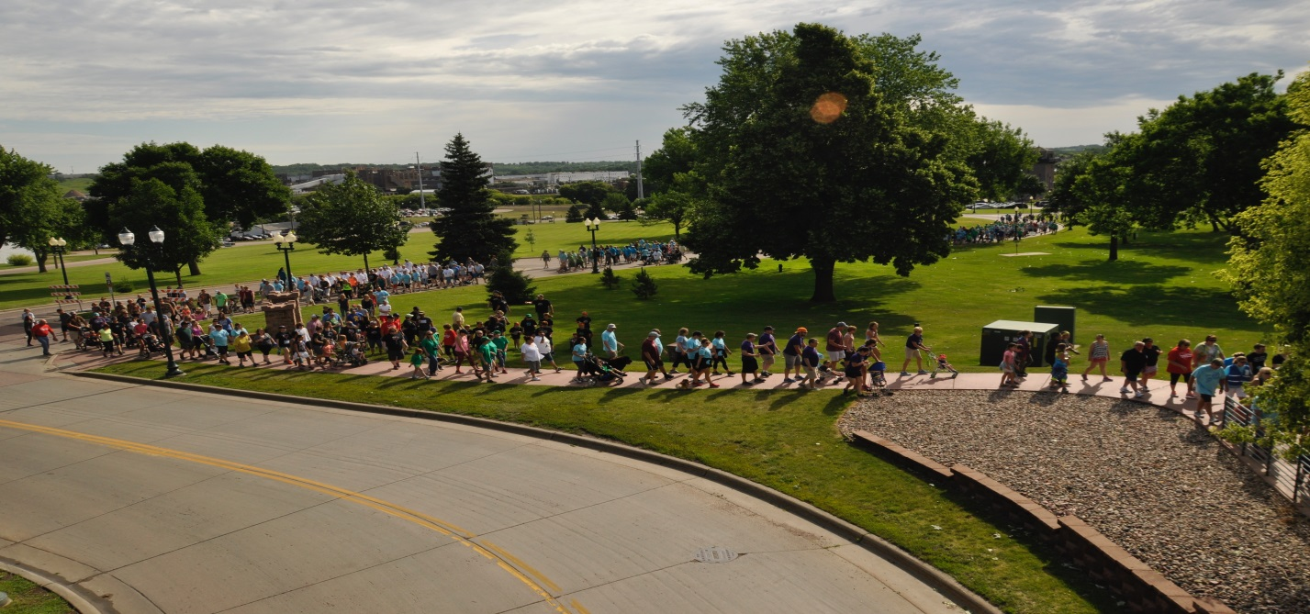

**Join us to make a difference on Saturday April 29, 2017 in Brookings on the campus of SDSU and Saturday June 17, 2017 in Sioux Falls at Falls Park.**

**Suicide grief: Healing after a loved one's suicide**

**A loved one's suicide can be emotionally devastating. Use healthy coping strategies — such as seeking support — to begin the journey to healing and acceptance.**

[By Mayo Clinic Staff](http://www.mayoclinic.org/about-this-site/welcome), Mayo Clinic Healthy Living (2015)

When a loved one dies by suicide, overwhelming emotions can leave you reeling. Your grief might be heart wrenching. At the same time, you might be consumed by guilt — wondering if you could have done something to prevent your loved one's death.

As you face life after a loved one's suicide, remember that you don't have to go through it alone.

**Brace for powerful emotions**

A loved one's suicide can trigger intense emotions. For example:

* **Shock.** Disbelief and emotional numbness might set in. You might think that your loved one's suicide couldn't possibly be real.
* **Anger.** You might be angry with your loved one for abandoning you or leaving you with a legacy of grief — or angry with yourself or others for missing clues about suicidal intentions.
* **Guilt.** You might replay "what if" and "if only" scenarios in your mind, blaming yourself for your loved one's death.
* **Despair.** You might be gripped by sadness, loneliness or helplessness. You might have a physical collapse or even consider suicide yourself.
* **Confusion.** Many people try to make some sense out of the death, or try to understand why their loved one took his or her life. But, you'll likely always have some unanswered questions.
* **Feelings of rejection.** You might wonder why your relationship wasn't enough to keep your loved one from dying by suicide.

You might continue to experience intense reactions during the weeks and months after your loved one's suicide — including nightmares, flashbacks, difficulty concentrating, social withdrawal and loss of interest in usual activities — especially if you witnessed or discovered the suicide.

**Dealing with stigma**

Many people have trouble discussing suicide, and might not reach out to you. This could leave you feeling isolated or abandoned if the support you expected to receive just isn't there.

Additionally, some religions limit the rituals available to people who've died by suicide, which could also leave you feeling alone. You might also feel deprived of some of the usual tools you depended on in the past to help you cope.

**Adopt healthy coping strategies**

The aftermath of a loved one's suicide can be physically and emotionally exhausting. As you work through your grief, be careful to protect your own well-being.

* **Keep in touch.** Reach out to loved ones, friends and spiritual leaders for comfort, understanding and healing. Surround yourself with people who are willing to listen when you need to talk, as well as those who'll simply offer a shoulder to lean on when you'd rather be silent.
* **Grieve in your own way.** Do what's right for you, not necessarily someone else. There is no single "right" way to grieve. If you find it too painful to visit your loved one's gravesite or share the details of your loved one's death, wait until you're ready.
* **Be prepared for painful reminders.** Anniversaries, holidays and other special occasions can be painful reminders of your loved one's suicide. Don't chide yourself for being sad or mournful. Instead, consider changing or suspending family traditions that are too painful to continue.
* **Don't rush yourself.** Losing someone to suicide is a tremendous blow, and healing must occur at its own pace. Don't be hurried by anyone else's expectations that it's been "long enough."
* **Expect setbacks.** Some days will be better than others, even years after the suicide — and that's OK. Healing doesn't often happen in a straight line.
* **Consider a support group for families affected by suicide.** Sharing your story with others who are experiencing the same type of grief might help you find a sense of purpose or strength. However, if you find going to these groups keeps you ruminating on your loved one's death, seek out other methods of support.

**Know when to seek professional help**

If you experience intense or unrelenting anguish or physical problems, ask your doctor or mental health provider for help. Seeking professional help is especially important if you think you might be depressed or you have recurring thoughts of suicide. Unresolved grief can turn into complicated grief, where painful emotions are so long lasting and severe that you have trouble resuming your own life.

Depending on the circumstances, you might benefit from individual or family therapy — either to get you through the worst of the crisis or to help you adjust to life after suicide. Short-term medication can be helpful in some cases, too.

**Face the future with a sense of peace**

In the aftermath of a loved one's suicide, you might feel like you can't go on or that you'll never enjoy life again.

In truth, you might always wonder why it happened — and reminders might trigger painful feelings even years later. Eventually, however, the raw intensity of your grief will fade. The tragedy of the suicide won't dominate your days and nights. Understanding the complicated legacy of suicide and how to cope with palpable grief can help you find peace and healing, while still honoring the memory of your love one.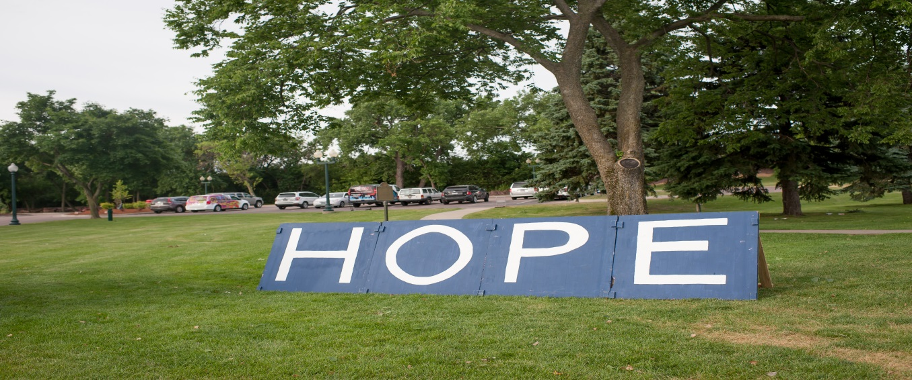

A PIECE OF HEALING: GRATITUDE SPEAKS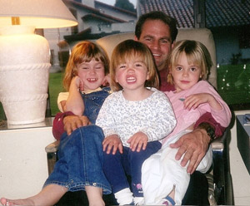

I have a stack of journals in my bedside table, “blank books” that are no longer blank.  Some of the handwriting is indistinguishable, because they were written in hurriedly, often in the middle of the night with the lamp dimmed so that my husband wouldn’t wake.  The dates when the entries were written were 11 years ago, when my life, family and heart were shattered, when my son Alan took his own life.

Now I am writing about feeling gratitude. Eleven years ago I couldn’t imagine feeling grateful about anything.  My life had been dramatically changed by the worst loss.  I scanned the journals today and grief returned, surprisingly painful and tearful.  But as fresh and acute as the grief is, I am also very aware how quickly it can be replaced by feelings of peace, love and yes, gratitude.

I have gratitude for the times when I am playing in the ocean waves with friends.  It is my meditation, when I am “in the moment”, mindful, and not thinking about my next appointment, my shopping list, the household tasks, financial issues, my losses. My world is calm and beautiful.

I am grateful for the holidays with my family that feel “normal” once more.  Anniversaries of birth, marriage, death.   The candle on the curb on Christmas Eve, where Alan always parked, makes his siblings and me smile because he loved Christmas so.  I don’t avoid those times but embrace them.  I share them openly with love and laughter with friends and family. And sometimes tears.

I am ever grateful for the people I would never have known except for that heartbreaking event in July 2003, the people that I met because they also lost a loved one.  We don’t dwell on our losses anymore, but celebrate their lives and ours.  That includes:

* The grandmother who had been a neighbor for years and we became close when her beloved granddaughter took her own life.  She has a delightfully wicked sense of humor and loves a martini now and then.  She is my friend.
* The woman whom I met when she lost her son to AIDS is now my friend.  She makes me laugh and we always find humor in adversity.  Good thing, ‘cause we both have had a lot of adversity!
* The man living down the street, whose license plate honored his dead son and who came to my door and comforted me when my son died.  Because of that he became a dear friend to my husband and me, celebrating birthdays and betting at the races.
* The lovely young woman who lost a brother to suicide and walks his dog in my neighborhood. She sells cosmetics, and subsequently treated my daughter and me to facials and makeovers, a lovely little respite which we enjoyed.
* The SOSL support groups I attended and worked with held a myriad of friends.  Those meetings were wrought with emotion, however I can’t think of one that didn’t include something to smile about and ended with hugs.
* It goes without saying I am ever grateful for my remaining family, Alan’s sister Susie and brother Scott.  When they were children it seemed that I never said one name without the other two following, my three kids.  The grief they had to overcome when their brother died doubled mine. Focusing on my missing child has been replaced with enjoying his brother and sister and their families to the fullest. My favorite photos of Alan show him with his young nieces.  My family fills my life with joy, adventure and humor. (Have I mentioned I love to laugh?)
* And finally I am deeply grateful for the many, many now-routine mornings, when I wake up and my first thought is not about losing my son.

There is no formula for how to survive loss, or how long it takes. Time heals but does not erase.  I never want to forget Alan. I read recently that no one is dead as long as their name is spoken.  I am grateful that I hear his name often and with gentle memories.

Christa Jewett Stahl

Posted on [August 15, 2014](https://www.soslsd.org/story/piece-healing-gratitude-speaks/)in Survivors of Suicide Loss(SOSL)

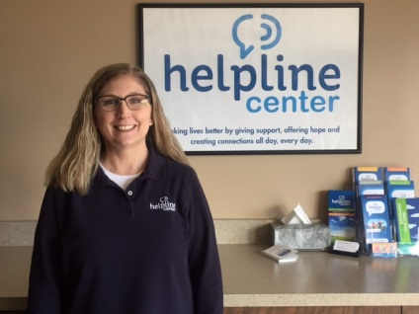Hi. I would like to introduce myself. My name is Sheri Nelson and I am the new Suicide Postvention Coordinator. My educational background is in addiction and psychology. In 2014 I furthered my education by getting my Master’s degree from the University of South Dakota. I have worked in the helping field for almost 19 years now and have worked in various roles. I started my career with working with at risk youth then moved on to work with adolescent females and women who were pregnant and parenting dealing with addiction and mental health issues. And most recently I had been working with adults who are dealing with co-occurring issues of addiction and mental health.

I have worked closely with clients who were struggling with their own suicide ideation and also those suffering from a loss of a family member by suicide, which made me realize that I wanted to continue to help to prevent suicide and work with people who have lost loved ones to suicide.

I look forward to meeting everyone and fulfilling my role as Suicide Postvention Coordinator.

**Surviving After Suicide (SAS) Support Group & 8-Week Class**

We will start our next SAS Class on March 28th, 2017. The Surviving After Suicide Class is held on Tuesday evenings from 7:00-8:30pm for 8 consecutive weeks at the Helpline Center. Registration is required and we ask that you commit to attending all of the 8 sessions. The supportive mourning process is guided by participant needs and a handbook organized chronologically to follow the days, weeks, and months after a suicide loss. It includes straightforward information and practical strategies for coping and healing.

To register, visit our website at http://helplinecenter.org/suicide-and-crisis-support/survivorservices/ and click on the Event Brite registration link under Support Classes or call the Helpline Center at 605-274-1416 or 211 and ask for Sheri.

SAS Monthly Support Groups are held the first Thursday of each month from 7:00-8:30pm at the Helpline Center - 1000 N. West Ave, Suite 310. Our support groups are held in an atmosphere that is warm and friendly and nonjudgmental. Anyone who has lost a family member or friend is invited to attend. Feelings shared are kept confidential and discussed only within the confines of the group meeting. Thus, our SAS support groups provide a comfortable, non-threatening setting to share our experiences and thoughts. Questions are encouraged to help in coping with the grieving process and with the feelings that are particularly intense in the aftermath of suicide. We end our discussion sessions by sharing something positive that has recently taken place or something good you are anticipating. There is no fee and no registration required.

**If you or a loved one is struggling with thoughts of suicide, please contact the Helpline Center 24/7 at 1-800-273-8255. A caring, nonjudgmental specialist will be happy to listen, provide help, hope, and support.**